Control and Smart Control main board replacement instructions
Included tools:
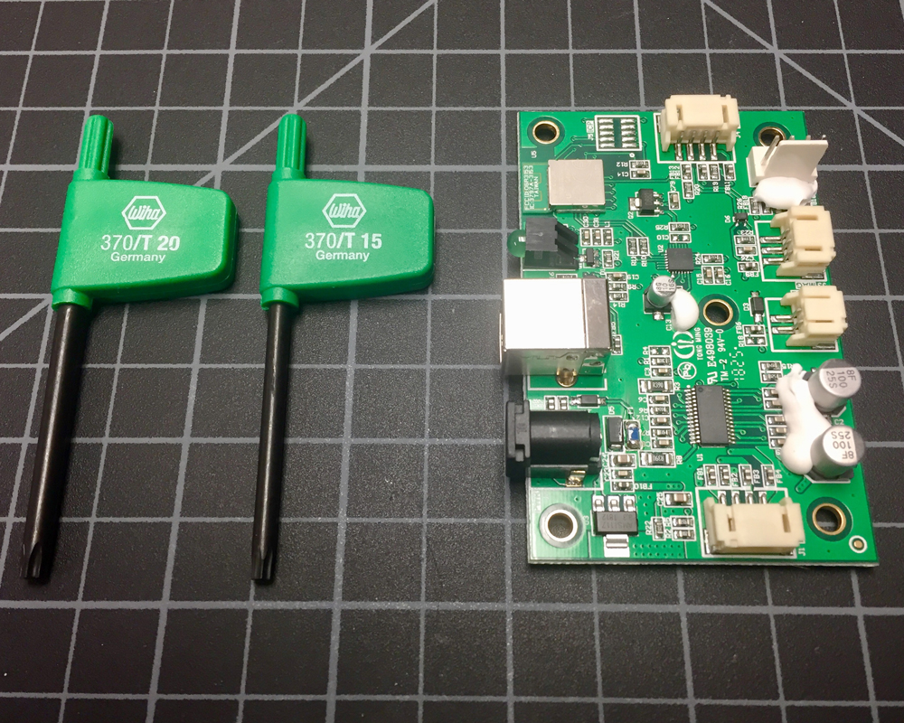

- Remove main housing (T-20 bit)
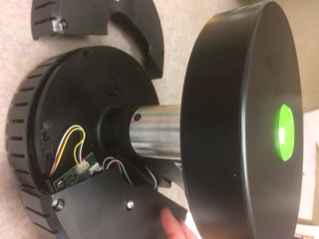
- With covers removed, main board is exposed
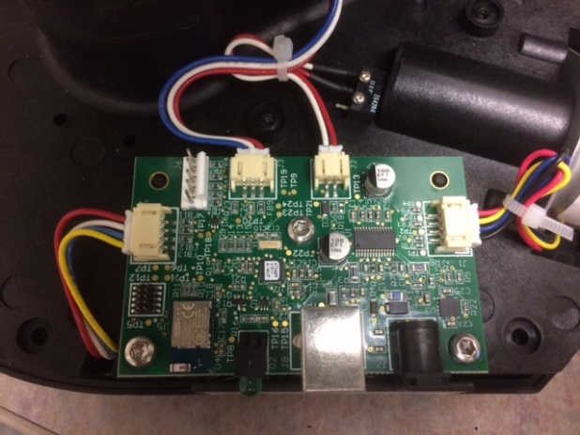
- Unplug the 4 cords from the board
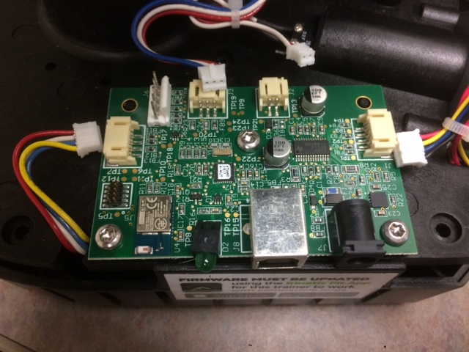

- Remove the three screws
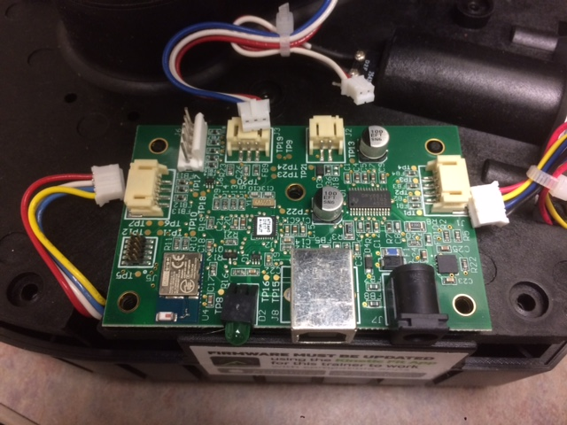
- Install the new board by reversing these steps.
- Reinstall covers
NOTE: CONTROL TRAINERS ONLY HAVE 3 WIRES. SMART CONTROL TRAINERS (SHOWN HERE) HAVE 4 WIRES.
Be sure to pair with the Kinetic Fit app and update firmware immediately after board installation.

